**Weather Data Analysis (Entry Level)**

**1.DESCRIPTIVE ANALYSIS**

Min Temperature

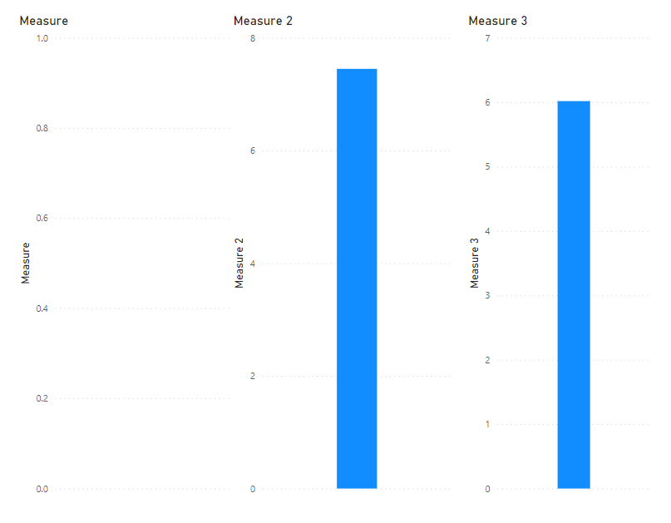

Max Temperature

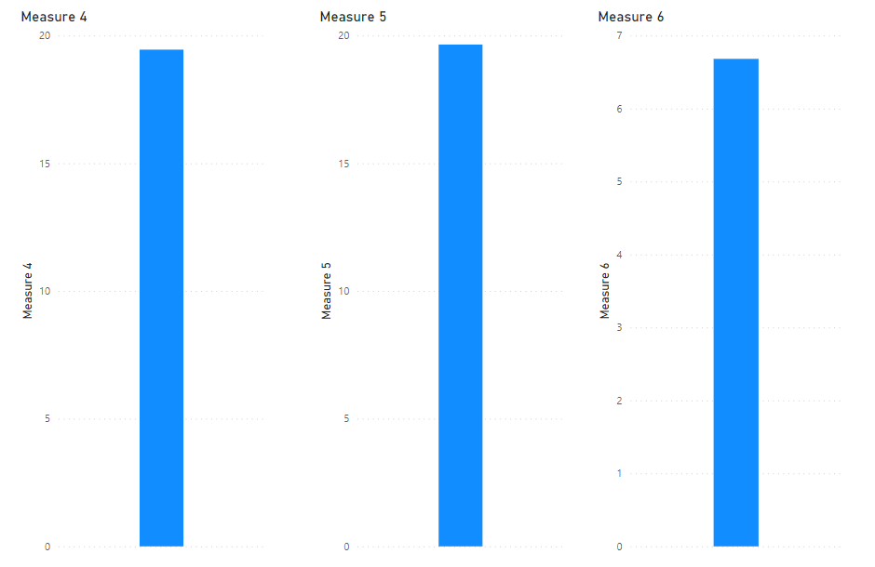

Rainfall

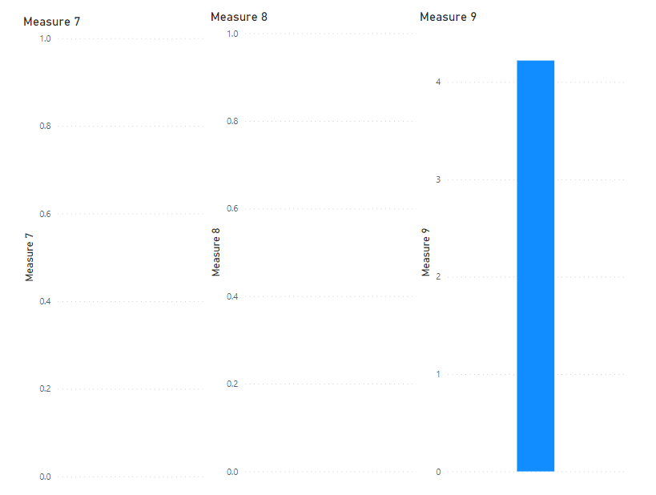

Evaporation

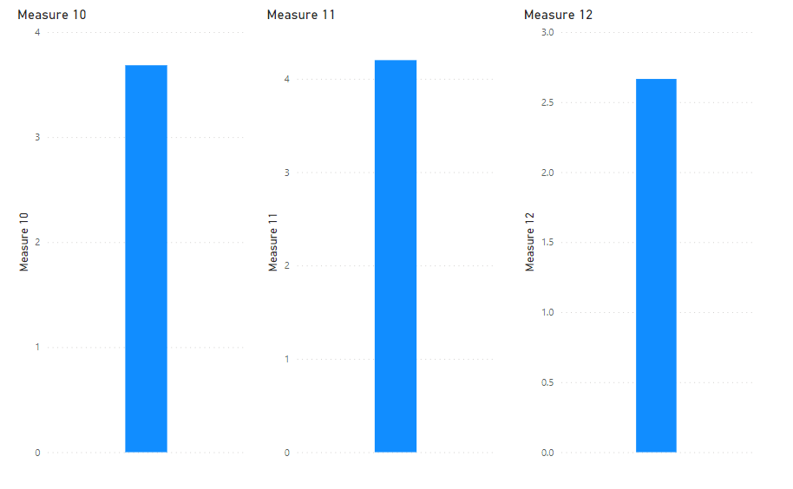

**2.Time Series Visualization:**

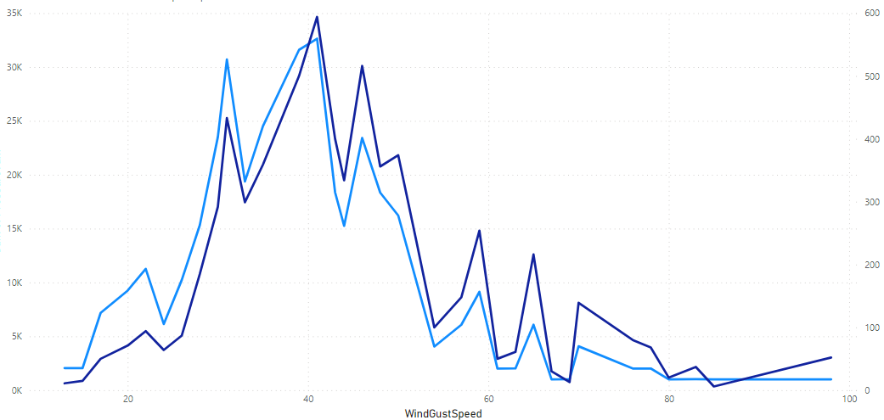

**3.Correlation Analysis:**

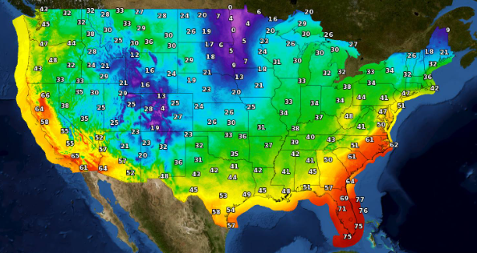

**4.Rainfall Distribution:**

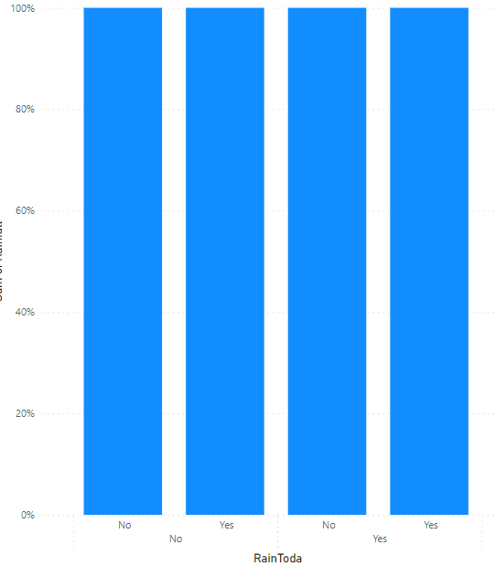

**5.** **Seasonal Analysis:** 